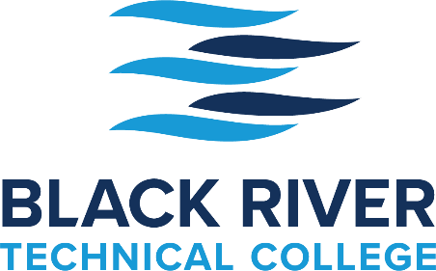

CDL Registration Checklist

All the steps below must be completed before Registration is complete.

- Purchase CDL Packet at the DMV
Take: Birth Certificate
Valid Driver’s License

- DOT Physical

- Current DOT Drug Screen

Back in Motion Chiropractic – (870) 248-0646
First Choice Healthcare – (870)892-9949
Pocahontas Medical Clinic – (870) 892-4467
This, in no way, is a comprehensive list but those we know who provide DOT Physicals in Pocahontas.

All the Above Steps (1 - 3)
Must be completed in the State that has issued the driver’s license.

- Complete BRTC Corporate & Community Education Registration Form

The fee ($3,500) for this five-week training program provides the participant with classroom training in preparation for the written permit test, range practice, behind the wheel driving time, and one trip to Newport to test in the same vehicle used during the training program. Additional training time after the program has concluded may incur an additional fee, to be determined. If needed, additional testing fees will be $125 each. Both of these additional fees will be the responsibility of the participant and will not be grant funded.
Cancellations must be made 24 hours prior to the beginning of the class. Once materials have been given to students for test preparation or the class has begun, there is a no-cancellation policy with a no-refund policy.
Permit must be obtained before admission to the driving portion of the class.
If participating in the Arkansas Department of Commerce, Office of Skills Development grant program, Reskilling and Upskilling Arkansans, your registration and participation obligates you to notify BRTC, Corporate & Community Eduation when you have obtained a job in the transportation industry, along with your pay rate and then again anytime you change postions for the next two years.
By registering for this class you acknowledge the above and that photographs and videos taken may be used in BRTC publications as well as area media.
- Make appointment with Adult Education to take Locator Test.

After all the above steps have been completed, the student will be placed in the next available class.

The schedule is as follows:

The Classroom portion of the class (8:00 a.m. – 4:30 p.m.) begins on Wednesday and continues through the next Tuesday for a 5-day, 40-hour class. Any time missed, must be made up.

Written/Permit tests should be taken on the next day, Wednesday, giving the student an opportunity to retake this test on Thursday and/or Friday, if necessary.

The four-week Driving portion of the Class begins the following Monday. Only students who have passed the written/permit test will be allowed to begin the Driving portion of the class.

Below is an example of our Class Schedule:

Wednesday, September 22 Classroom Begins
Wednesday, September 29 Written/Permit Test Taken
Monday, October 4 Driving Begins
Thursday, October 28 Testing – Actual Date May Vary due to Testing Schedule

If you have any questions please call 870-248-4180.

