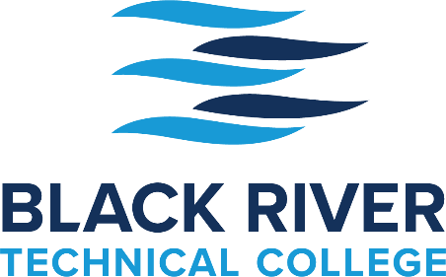

CDL Registration Checklist

Students must complete all steps below before registration is complete.

- Purchase CDL Packet at the DMV
Take: Birth Certificate
Valid Driver's License

- DOT Physical

- Current DOT Drug Screen

Back in Motion Chiropractic – (870) 248-0646
First Choice Healthcare – (870) 892-9949
Pocahontas Medical Clinic – (870) 892-4467
This is not a comprehensive list, but those we know who provide DOT Physicals in Pocahontas.

The Above Steps (1 - 3)
Must be completed in the state that has issued the driver's license.

- Complete CDL Training Registration Form and Confirm Payment

The $3,500 fee for this five-week training program provides the participant with classroom training in preparation for the written permit test, range practice, behind-the-wheel driving time, and one test date in Newport in the same vehicle used during the training program. After the five-week program has concluded, additional training time may incur an additional fee, to be determined. If needed, additional testing fees will cost $125 each.
Cancellations must be made 48 hours before the beginning of the class. Once materials have been given to students for test preparation or the course has begun, there is a no-cancellation policy with a no-refund policy.

CDL Registration Checklist
Page 2

- Make an appointment with Adult Education to take the Locator Test.

After all the above steps have been completed and the appropriate paperwork submitted, the student will be placed in the next available class.

Course Schedule:

The course's Classroom portion (8:00 a.m. – 4:30 p.m.) is a five-day, 40-hour course.
Students should take the written permit test as soon as possible after the conclusion of this class. As soon as the student has the permit, submit a copy to BRTC.

Students must obtain a permit before admission to the Driving portion of the class.

The course's Driving portion (7:00 a.m. – 5:00 p.m.) is Monday through Thursday for four weeks.

If you have any questions, please call 870-248-4180.

Funding:

If Needing Funding - Meet with Adult Education to Screen for External Funding Sources. Please call 870-248-4130.

Application for WIOA
To apply for WIOA Funding, please visit: http://www.neaworks.com/application
Please let us know if you are eligible for WIOA funding after you have received a response.

Application for the Arkansas Workforce Challenge
To apply for the Arkansas Workforce Challenge, please use the following link:
https://explorearcareers.com/?gclid=Cj0KCQiA9OiPBhCOARIsAI0y71AiwFWtovULmZ6zyXdJMRjLlbAvi2FohNxKQzGquQdIqvwgGe5WFh0aAgj2EALw_wcB or visit explorearcareers.com.
We will need a copy of a high school diploma or transcript or a GED Certificate to submit after application. If you have this, you should be eligible to receive an $800 scholarship paid to BRTC. Watch for an email from them 1-2 weeks after you make the application. You will need to accept the award in the email.

Application for a SallieMae Loan

www.salliemae.com
Click "Apply Now," which leads to the page below. Choose the option "Career Training School." Next, indicate how much you want to borrow ($3,500 - $3,700), and a credit check will be made. Afterward, Sallie Mae will email an electronic certification request to BRTC to verify the student's enrollment. The funds will be sent to BRTC by paper check and will need to be endorsed by the student.

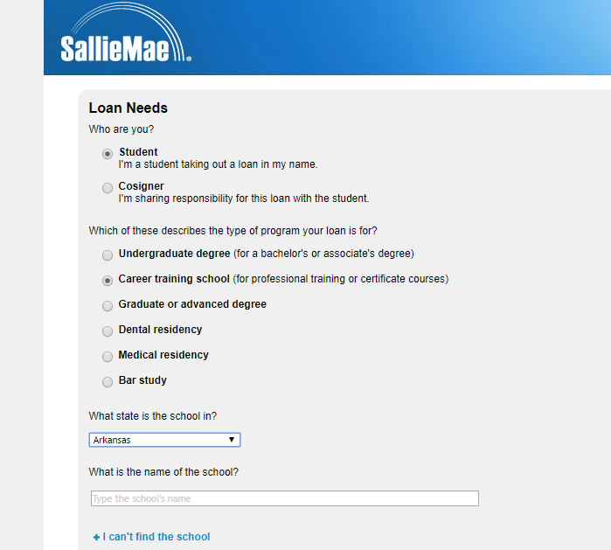

Contact Brandi Chester with any questions regarding this process.

Brandi Chester BS, MSE
Director of Financial Aid
Black River Technical College
P.O. Box 468
Pocahontas, AR 72455
PH: (870) 248-4000, Ext. 4020
FAX:(870) 248-4100
brandic@blackrivertech.edu

